Introduction
Visually impaired individuals face difficulties in independent and safe navigation.
Existing tools like white canes detect only close ground-level obstacles and provide no object awareness, creating safety limitations for visually impaired users.
A low-cost, intelligent assistive device that offers reliable obstacle detection and voice-based awareness is needed to improve independence and confidence.
So, our project aims to develop AI-Enabled Smart Ultrasonic Glasses to assist visually impaired individuals in safe navigation.
The system combines ultrasonic obstacle detection with YOLO-based AI vision object recognition to offer both vibration and voice alerts.
This ensures real-time safety, object awareness, and voice-based guidance for visually impaired users.
Ultrasonic sensors provide reliable obstacle detection, while existing tools like smart canes lack object identification.
Research shows that combining ultrasonic sensing with YOLO-based AI improves object awareness and overall user safety.

Objectives
To detect nearby obstacles accurately using ultrasonic sensors.
To provide immediate vibration alerts for user safety.
To identify surrounding objects through YOLO-based AI vision.
To deliver voice-based feedback for improved environmental awareness.
To implement a fail-safe system that works even if AI detection fails.
To design a lightweight, ergonomic, and cost-effective wearable device.
To enhance independence and mobility for visually impaired individuals.

Societal Impact
Enhances independence and mobility for visually impaired individuals through real-time alerts.
Reduces accidents by providing continuous vibration and voice warnings.
Boosts user confidence in navigating crowded or unfamiliar environments.
Makes smart assistive technology more accessible due to low cost and simple design.
Reduces dependence on others, promoting dignity and self-reliance.
Encourages further innovation in AI-based assistive and wearable technologies.

🔵 Methodology
Ultrasonic sensors continuously measure the distance of nearby obstacles, and the ATmega328P microcontroller processes this data to activate vibration motors for immediate alerts.
Obstacle information is sent to the Raspberry Pi 3 B+ through Rasoberry Pi Camera Module 2 to synchronize AI and safety responses.
The Raspberry Pi captures live video using the 8 MP camera module and processes each frame using YOLO and OpenCV for real-time object detection.
Python is used to implement AI detection, serial data handling, and text-to-speech generation through pyttsx3.
The entire wearable setup operates as a fail-safe system and is tested for accuracy, responsiveness, and usability.

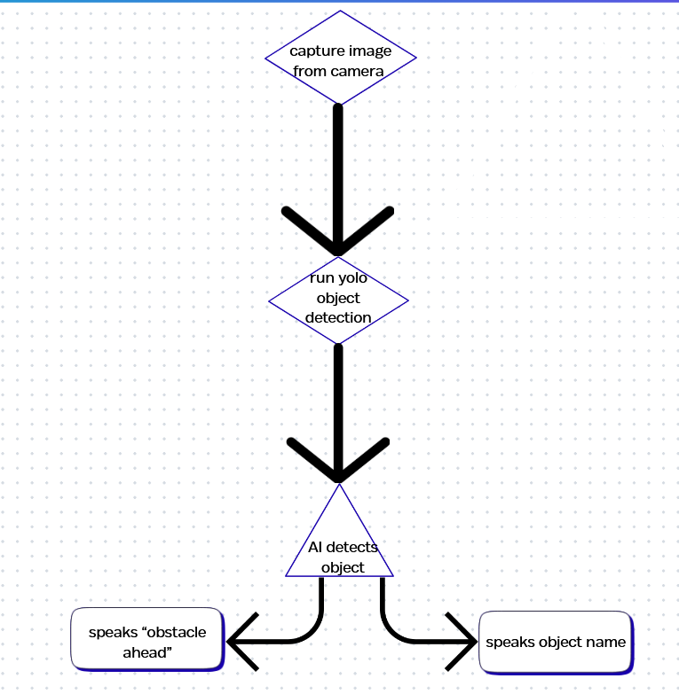
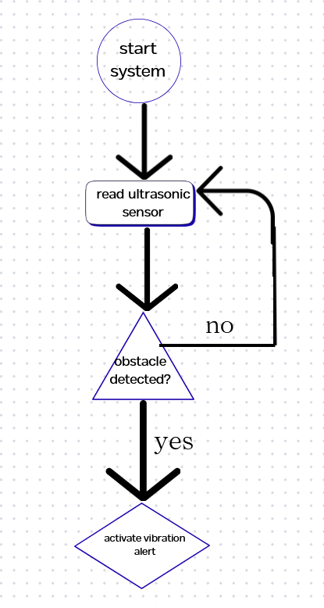

🔵 Experimental / Simulation Outcome
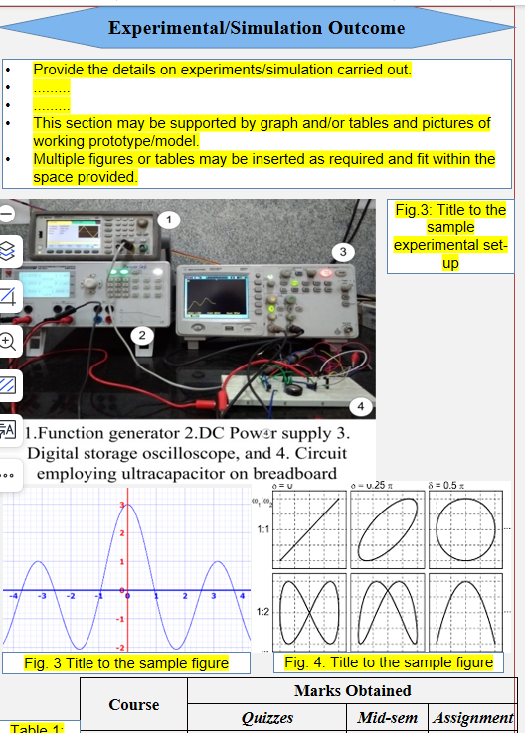

🔵 Conclusions
The project successfully integrates ultrasonic sensing with YOLO-based AI vision to provide both obstacle detection and object awareness for visually impaired individuals.
The system is lightweight, wearable, affordable, and effective for real-time navigation support.
The prototype demonstrates strong potential for practical assistive applications and future enhancement with advanced AI models and navigation features.
The combination of AI and embedded systems showcases an efficient, low-cost solution that can significantly improve accessibility and user independence.

Future Work
Integrating GPS-based navigation to provide turn-by-turn guidance.
Adding a mobile application for monitoring, updates, and customization.
Upgrading to faster AI models or using hardware accelerators for improved detection speed.
Enhancing performance under low-light conditions with infrared or night-vision support.
Implementing bone-conduction audio for safer and more comfortable voice feedback.

References (in IEEE format)
[1] S. K. Yelure and B. Pawar, “Smart stick for blind obstacle detection using ultrasonic sensors,” International Journal of Advanced Research in Electrical, Electronics and Instrumentation Engineering, vol. 6, no. 4, pp. 2319–2324, Apr. 2017.
[2] P. Meenakshi, R. Mishra, and P. Saini, “Smart glasses for visually impaired using ultrasonic sensors,” International Journal of Engineering Research & Technology (IJERT), vol. 9, no. 5, pp. 450–454, May 2020.
[3] R. B. Dubey and P. Singh, “Obstacle detection system for visually impaired persons,” Proceedings of the International Conference on Inventive Research in Computing Applications (ICIRCA), Coimbatore, India, pp. 123–128, Jul. 2018.
[4] A. S. Al-Fahoum, H. B. Al-Hmoud, and A. A. Al-Fraihat, “A smart assistive system for blind and visually impaired people,” International Journal of Engineering and Technology Innovation, vol. 3, no. 1, pp. 11–18, Mar. 2013.
[5] D. Dakua, “Wearable smart navigation system for visually impaired using real-time sensor fusion,” IEEE Sensors Letters, vol. 4, no. 9, pp. 1–4, Sept. 2020.
[6] A. N. Ansari, S. Navada, S. Kokate, and S. Chavan, “Smart guide cane for visually impaired persons,” IEEE International Conference on Engineering and Technology (ICETECH), Coimbatore, India, Mar. 2016.
[7] S. L. Jose and D. Prabha, “Assistive device for visually impaired using IoT,” 2019 IEEE International Conference on Intelligent Computing and Control Systems (ICICCS), Madurai, India, May 2019.

